MY DAUGHTER MY DAD
MY ACTRESS DAUGHTER, MODEL, VOICE OVER ARTIST LISA MARIE THOMAS
MY DAD WOODIE H. THOMAS, III, ESQ, PHD

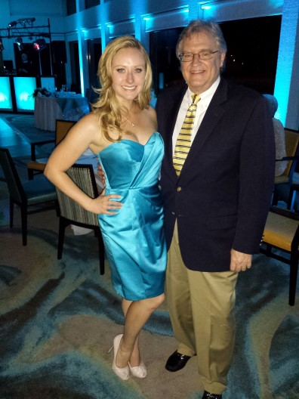

DEDICATION

The birth of my daughter, Lisa Marie Thomas, is the most important event in my life. Lisa appeared in the 2011 FOOTLOOSE with Julianne Hough, The Walking Dead, Vampire Diaries, Hope Dancer, etc. My daughter is the primary inspiration in my life and for writing this book. I’m publishing a book about my extraordinary relationship between a father and daughter, entitled “MY DAUGHTER/MY DAD”. My plan is for my daughter Lisa Marie to be inspired to write “MY DAD”.
Google: Lisa Marie Thomas IMDB

CHAPTER ONE

THE FIRST FIVE YEARS
LISA MARIE THOMAS
WAS BORN MAY 8, 1986 AT 10:30 A.M.
ST. MARY'S HOSPITAL
WEST PALM BEACH, FLORIDA

CHAPTER TWO

LISA MARIE THOMAS
EDUCATION HISTORY

- Clifford O. Taylor/Kirklane Elementary School Palm Springs, Florida
- Lisa Marie Thomas, was in the first graduating class of the public school Bak Middle
School of the Arts,West Palm Beach, Florida majoring in Theatre.
- Lisa Marie Thomas, was in the first graduating class of the public school Dreyfoos High School of the Arts.West Palm Beach, Florida majoring in Theatre.
- Lisa graduated from Florida State University in four years with two Bachelor of Science (B.S.) degrees Magna Cum Laude in FINANCE and MARKETING with a minor in COMMUNICATIONS .

CHAPTER THREE

.

CHAPTER FOUR

CHAPTER FIVE

CHAPTER SIX
MOVIES AND TELEVISION

Lisa appeared in FOOTLOOSE II 2011 with Julianne Hough, THE WALKING DEAD, VAMPIRE DIARIES, HOPE DANCER, ETC. GOOGLE: LISA MARIE THOMAS IMDB

CHAPTER SEVEN

LISA'S MARRIAGE
Lisa was married June 8, 2023 with all of her family and friends to Chistopher Tung, a NETFLIX executive, in Maui, Hawaii.

